**SPRINT 2**

|  |  |
| --- | --- |
| Date | 10 November 2022 |
| Team ID | PNT2022TMID19760 |
| Project Name | Smart farmer – IOT Enabled Smart Farming Application |

Sensor Connection

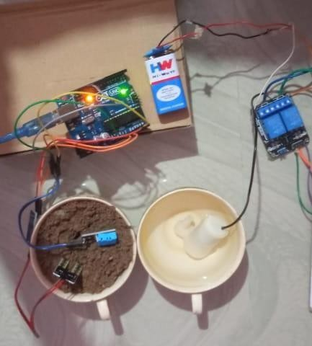

Device Details:

